SIMATS ENGINEERING
ASSESSMENT TOOL 2

COURSE NAME: Database Management Systems
COURSE CODE: CSA05

COURSE OUTCOME COVERED

CO1: Analyse DBMS architecture, different data models, schema types, and design ER/EER diagrams, relational schemas for case-based scenarios by identifying entities and relationships. (BL1, BL2)

Activity Tool : Concept Mapping (Medium)
Assessment Tool Weightage: 20%

QUESTIONS
Q.N o | Question | Bloom's Level
1 | Construct a concept map linking the following terms: DBMS, Schema, Instance, Data Model, ER Diagram, Entity, Attribute, Relationship. | BL2 – Understand
2 | Create a concept map for the three-level ANSI/SPARC architecture showing data independence at each level. | BL2 – Understand
3 | Map the relationship between file-based systems and database systems, highlighting the problems solved by DBMS. | BL2 – Understand
4 | Design a concept map for ER diagram components: entity, weak entity, attribute types, relationship types, and participation constraints. | BL2 – Understand
5 | Construct a concept map comparing Hierarchical, Network, and Relational data models with their key properties. | BL2 – Understand
6 | Develop a concept map for the EER model showing how it extends the basic ER model with generalization, specialization, and aggregation. | BL2 – Understand
7 | Create a visual concept map for the DBMS software architecture, illustrating the flow from user request to data retrieval. | BL2 – Understand
8 | Map the data models discussed in CO1 to real-world applications and explain the suitability of each model. | BL2 – Understand
9 | Construct a concept map for schemas and instances, showing how they relate to physical and logical data independence. | BL2 – Understand
10 | Design a concept map for the roles and responsibilities in a DBMS environment: DBA, End User, Application Developer. | BL1 – Remember

Code of Conduct:
Criteria | Weightage | Level 4 (Exemplary) | Level 3 (Proficient) | Level 2  (Developing  ) | Level 1 (Beginning)
Concept  Identification | 25% | Identifies all key concepts from literature  accurately and  comprehensivel  y | Identifies most key concepts  with minor omissions | Identifies limited  concepts; some are  irrelevant or missing | Fails to identify  essential concepts
Linkages | 25% | Establishes clear,  meaningful, and accurate  relationships between concepts | Shows correct  relationships  with minor gaps | Relationship  s are weak,  unclear, or partially incorrect | No meaningful relationships established
Organization | 20% | Concepts are well-structured hierarchically  with logical flow and grouping | Mostly organized  with minor  structural issues | Some  organization but lacks clear hierarchy | No logical organization or structure

I Gunavathi. A (192511374) (Name / Reg No) certify that this submission is my original work and that I have adhered to the guidelines specified for this assessment. I understand that any violation of academic integrity rules will result in disciplinary action.

- Gunavathi
Signature of the student:

- Construct a concept map linking the following terms: DBMS,Schema, Instance, Data Model, ER Diagram, Entity, Attribute,Relationship.

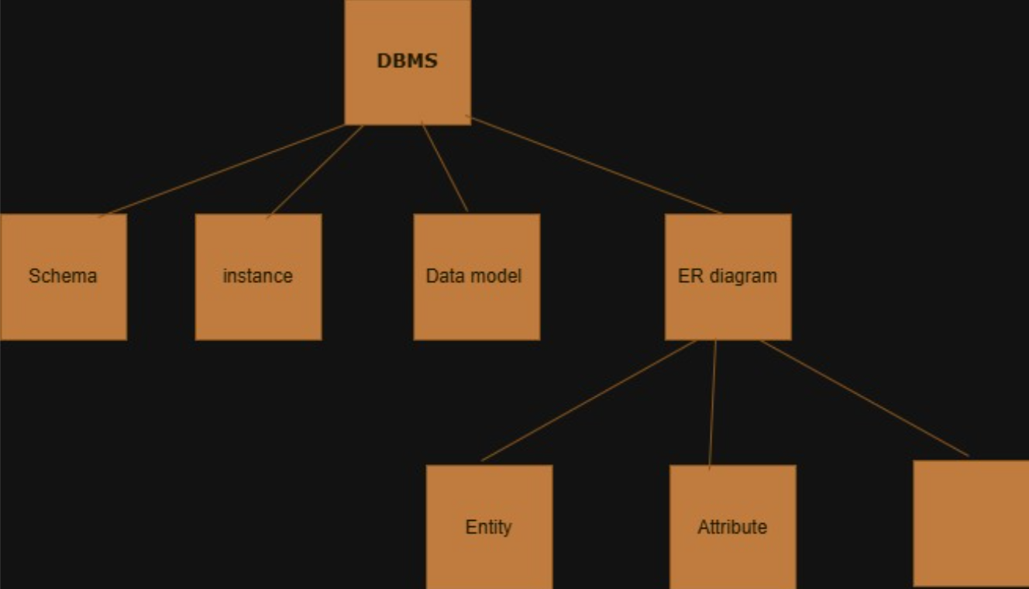

2)Create a concept map for the three-level ANSI/SPARC architecture
showing data independence at each level.

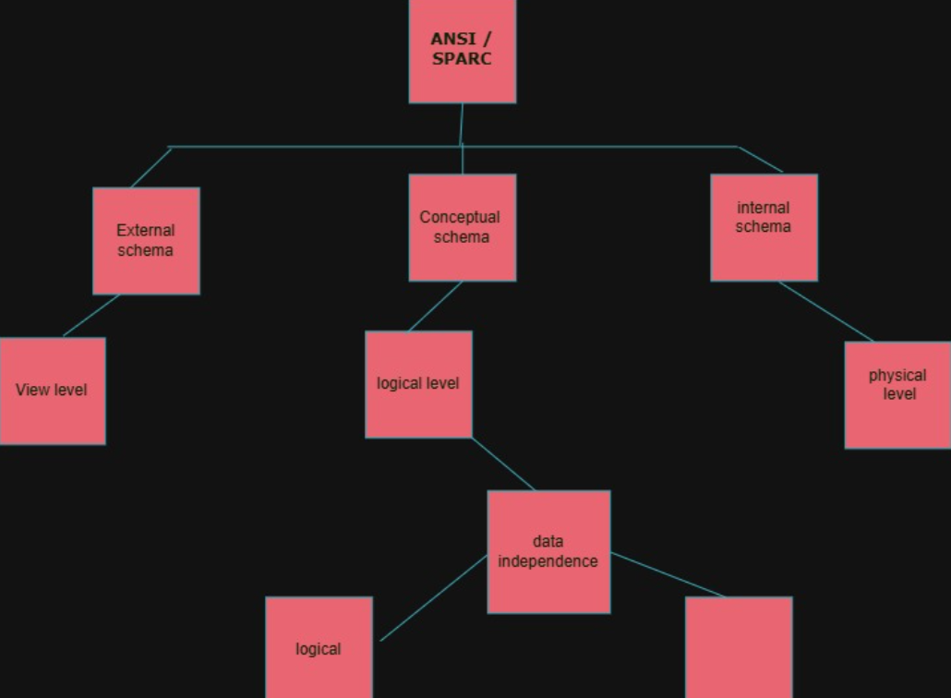

3) Map the relationship between file-based systems and databasesystems, highlighting the problems solved by DBMS.

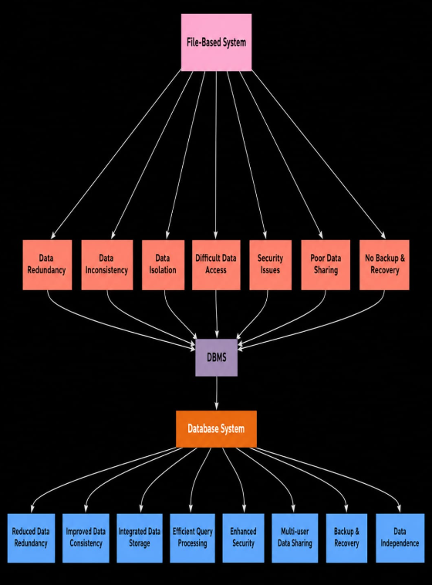

4) Design a concept map for ER diagram components: entity, weakentity, attribute types, relationship types, and participationconstraints.

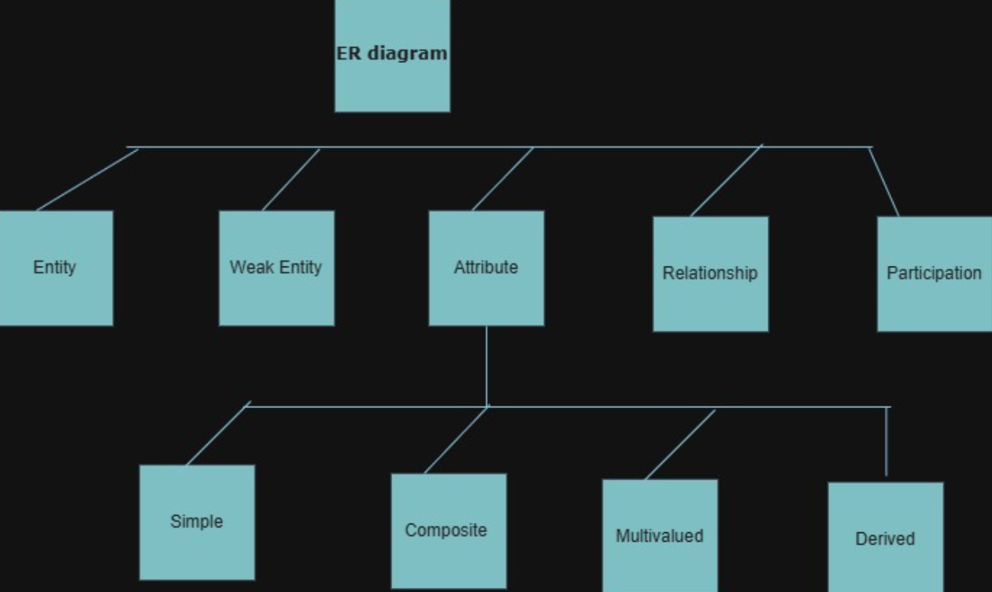

5) Construct a concept map comparing Hierarchical, Network, andRelational data models with their key properties.
